

**2021 Central Illinois Tennis Association**

**Winter Jr. Team Tennis League**

***MATCH FORMAT***

* Teams will consist of a minimum of 3 boys & 3 girls, competing in singles, doubles, and mix
* Each match includes 1.5 hrs. of match play. Double headers are 3 hrs.
* Total number of games won by the team determines match winner.
* Each team will play a minimum of **10 matches**.

***HOW TO JOIN/FEES***

* $105 player fee (include balls, court time and t-shirts)
* **No USTA membership required**
* **No club membership required**
* To join go to [www.usta.com](http://www.usta.com), click on “Tennislink”, click on Junior Team Tennis, under USTA Junior Team Tennis click on “Have a Team ID”, enter your team number below & click “Enter”, enter your USTA # & “Proceed to Checkout” , then click “Submit”. Credit card needed.

**REGISTRATION TEAM #S**

**18U**: 8570411262 **14U**: 8570411265

**12U**: 8570411264 **10U**: 8570411266

***LOCATION, DATES, & TIMES***

* Matches will be played at Springfield Racquet & Fitness Center 3725 Chatham Rd. Springfield, IL 62704.
* Matches will mostly be on Fridays or Saturdays, but some matches maybe on weekdays due to Covid-19 regulations. Start date: January 2, 2021-March 6, 2021

**If you have questions, please contact Sonthana Thongsithavong at**

**217-381-5406 or sonthana@midsouthillinoistennis.com.**

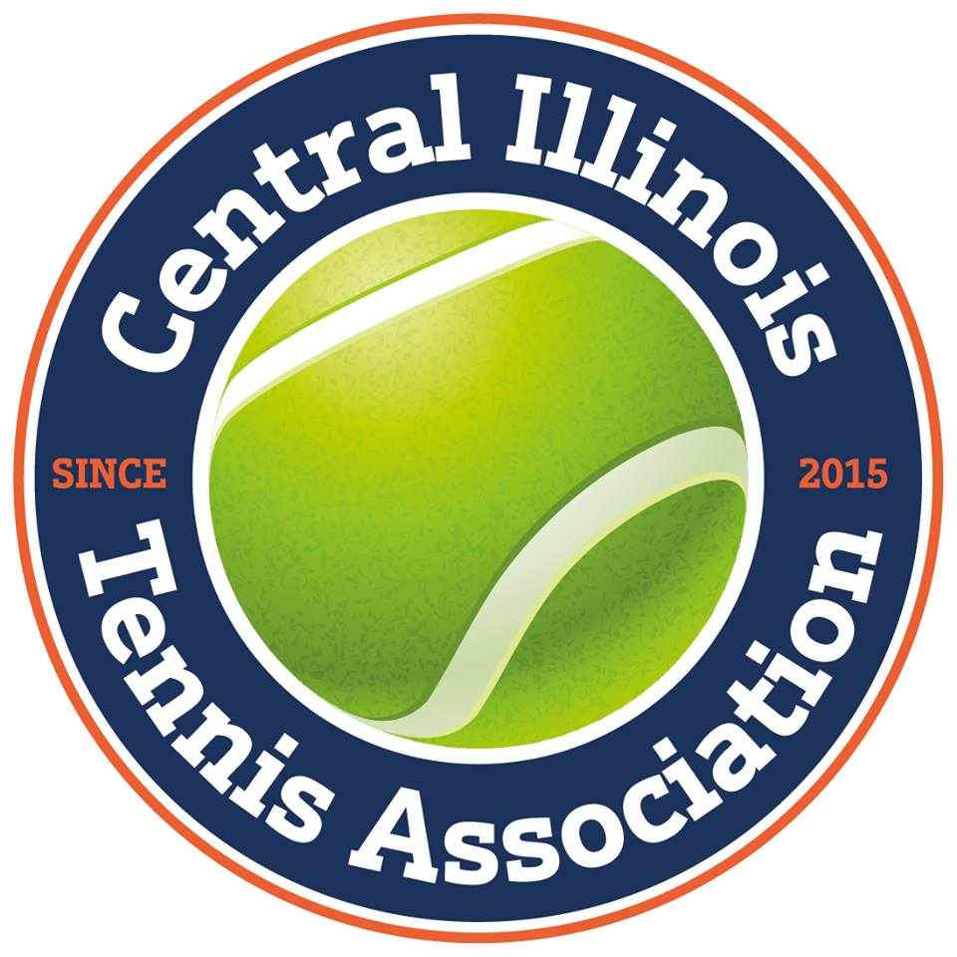

**USTA/Mid-South Tennis**